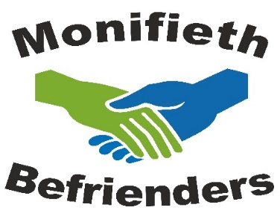

Before you can meet with someone at home it is important that you have a deeper understanding of what your role as a befriender is, what to expect and how you are supported throughout the year, so in the week beginning 15th June, I will be running a series of introductory sessions via Skype, lasting around an hour to an hour and a half.

I hope to do these with groups of six and would like you to get together with your chosen partner, where possible.

The times are Monday 15th, Tuesday 16th, Wednesday 17th from 10am -12pm and 1pm -3pm.
Thursday 18th from 10am-12pm only.

I will allocate times on a first come first served basis, so let me know, as soon as possible, what suits you best.

Please note that you cannot become a Befriender until you have taken part in these workshops.

