Monifieth High School
Transition Workbook
2020

Welcome to Monifieth High School

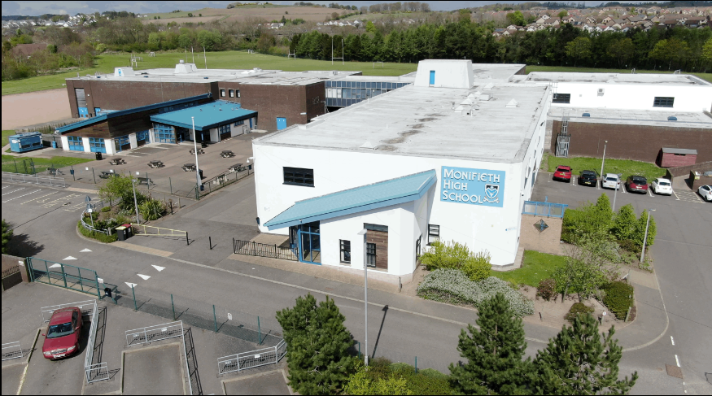

Moving from Primary to Secondary School is an exciting, but sometimes scary time! A new building, new rules, new teachers, new routines and new friends are just some of the changes you will experience but this booklet will help you get used to some of the routines and features of your new school!

While we hope the information will be accurate when things return to normal schooling, during this period of COVD 19 some of the information in this booklet will not be what you will experience until we have a relaxation on social distancing and other health and safety regulations.
Meet our Senior Leadership Team

Mrs McInally
Headteacher

Dr Matthew Mrs Ritchie Mr Lusby
DHT – Balmossie DHT – Dalhousie DHT - Panmure

Mrs Smith
School Business Manager

Meet our Pupil Care & Support Staff

Balmossie Dalhousie
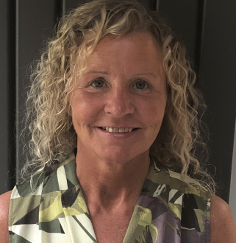

Mrs Welsh Mrs Whitfield Mr Burns Mrs Perry

Panmure

Mr Tragham Miss Herbert

As you can see there are 6 members of our Pupil Care & Support Team. We will teach you Social Education one period per week where we cover topics such as :-
- Friendship
- Bullying
- Alcohol & Other Drugs
- Keeping Yourself Safe
- Careers Education
- Online Safety
- Mental Health & Wellbeing and much more.

We are here to help if you have any questions or problems in or out of school. As you move up school we also help you with course choice as well as applying to college, university or jobs.
We are also the point of contact for your parents if they have any queries or questions about your progress at school.
HEART TEAM

Mrs Anderson Claire Morrison
PT HEART Resource Worker

Mrs Anderson and Claire Morrison work very closely with your PC&S Team. They are part of our HEART Team. Our HEART Team want to ensure that all MHS pupils are Healthy, Engaging, Achieving, Relating and Thriving.
Mrs Anderson is based in The Hub which is a small classroom near our school office. Pupils attend there for various reasons as needing a bit of extra support in a subject or just needing some support if you are upset.
Claire Morrison is our Resource Worker and she works with pupils who may need support with friendships, relationships and emotional wellbeing.
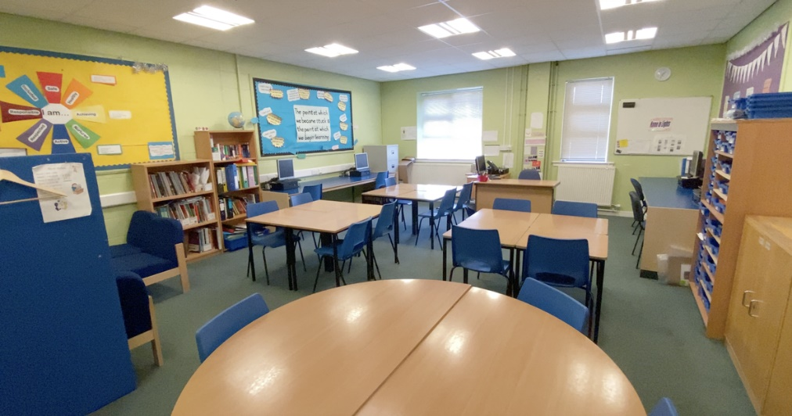

The Hub classroom

Additional Support Needs (ASN) Department
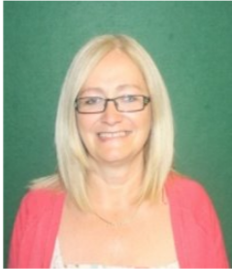

Mrs Wainwright
PT ASN

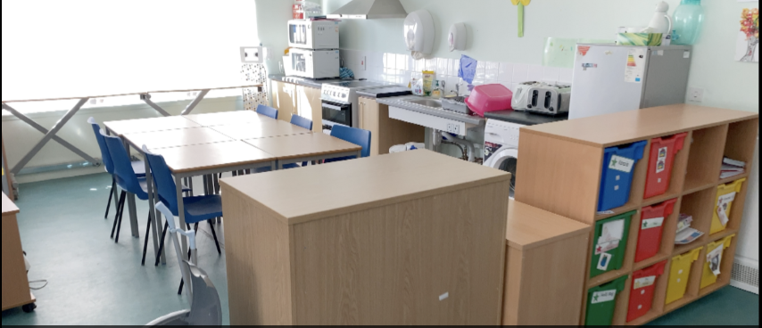
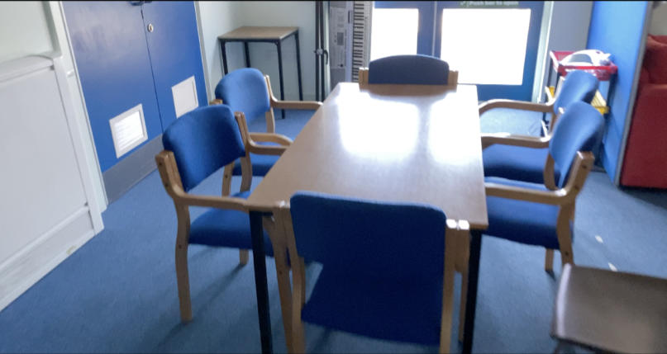
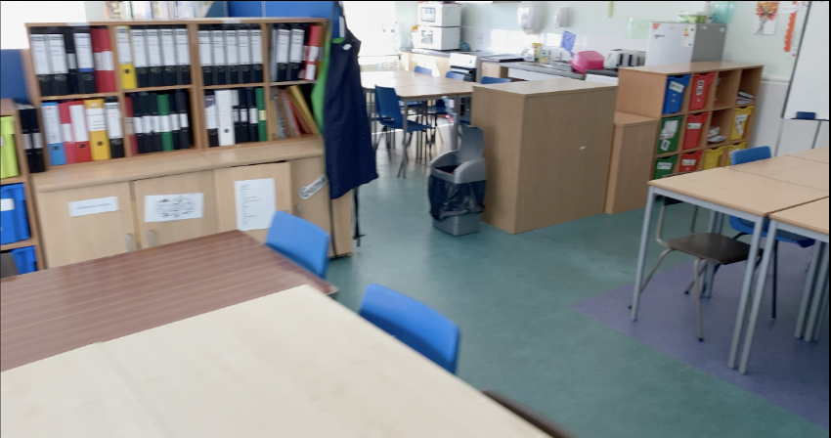
You might attend ASN for extra support in small groups or for some precision teaching.
Inside our ASN Department
Draw a self portrait or write a list of words that best describe you.
Name:

Birthday:

My Primary School:

Eye Colour:

Hair Colour:

Height:

Favourite Colour
Favourite Animal
If I could have a superpower, I’d….
Favourite School Subject
Best place I’ve ever been to…
Dream country to visit…
If I could travel back in time, I’d go to…
My dream job is…

Life is a journey! Think back through primary school and write down your favourite memories or events that have shaped you to become the amazing person you are!
Add 10 words around the image below to describe Monifieth High School.
Full Name of the School
School Address
School Telephone Number
Name of the Head Teacher
School Starts at
School Finishes at
I will get to school by
How long will it take you to get to school?
What time will you have to leave home?

- List 4 things you are most excited about moving to Monifieth HS.

4.

- List 4 things you are a little worried/nervous about.

- List 4 things you would like to know about Monifieth HS.

- List 4 things that will help you when moving to Monifieth HS.

- List 4 differences between your primary school and Monifieth HS.

Find some of the subjects below in the Word search – they are vertical, horizontal and diagonal!
S | A | F | S | E | H | M | G | E | O | H | I | M | J | E | E | A
O | M | A | M | W | S | L | U | S | M | I | S | E | T | N | I | S
C | U | D | R | A | M | A | Z | S | A | C | P | N | G | E | A | I
I | F | G | T | R | N | G | I | S | E | D | A | L | T | I | N | U
A | R | R | H | P | G | R | T | E | N | C | I | T | O | C | A | O
L | T | M | S | L | U | B | N | Y | R | S | N | E | R | S | S | L
E | U | B | P | E | I | C | Q | L | H | R | M | X | T | A | S | S
D | E | A | U | S | E | M | U | A | H | S | U | D | I | N | E | P
U | F | X | L | G | E | O | G | R | A | P | H | Y | M | D | M | A
C | I | M | T | V | M | S | I | T | Y | E | O | A | E | M | B | N
A | O | A | I | I | O | T | O | H | R | T | T | S | C | O | L | I
T | P | T | E | E | L | G | R | D | U | S | E | R | A | R | Y | S
I | P | U | F | O | S | E | E | K | R | H | P | T | T | A | E | H
O | I | Y | R | O | T | S | I | H | S | T | S | M | E | L | R | A
N | N | J | V | E | P | I | F | J | N | A | M | U | R | S | B | K
J | K | H | O | M | E | C | O | N | O | M | I | C | S | P | U | M
Y | Z | X | T | L | S | V | Z | I | C | T  Maths English Science  Geography History Art  Music PE Drama  Design RMPS Home Economics  ICT Spanish Social Education | u | T | N | G | M | O

This is an example of an S1 timetable. Yours will look something like this:-
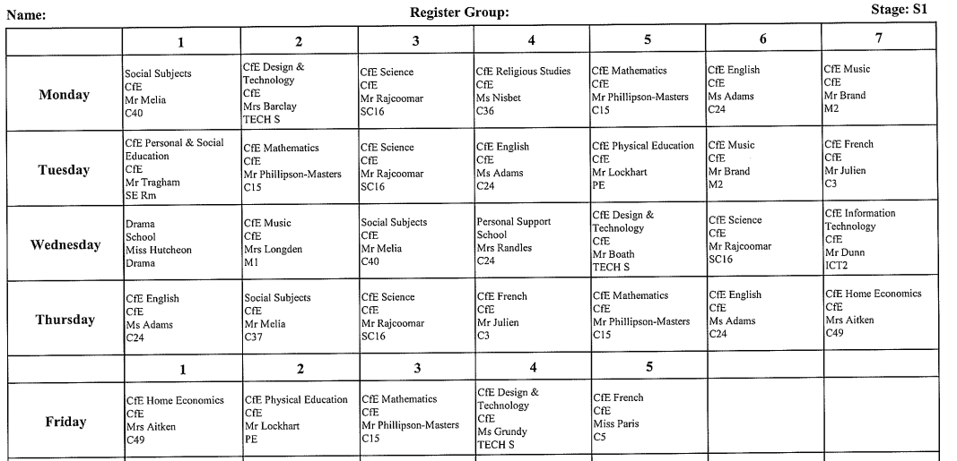

Our School Day
8.55 – 9.45 Period 1
9.45 – 10.35 Period 2
10.35 – 11.25 Period 3
11.25 – 11. 40 Break
11.40 – 12.30 Period 4
12.30 – 1.20 Period 5
1.20 – 2.10 Lunch
2.10 – 3.00 Period 6
School finishes at 1.20pm on a Friday.
3.00 – 3.50 Period 7

When you go to Secondary School, you will learn a huge number of new skills, and improve skills you have practiced in Primary School. In the goal below, use the list to write in 10 new skills or things you would like to build on in your years at Secondary School.
Learn to play a musical I instrument. | Learn to play a new sport. | Learn a foreign language. | Join a lunchtime or after school club.
Play for a school team. | Learn to cook. | Volunteer in my local community. | Perform in a school show,
Make new friends. | Be a School Captain | Learn how to read a map | Raise money for charity
Learn First Aid | Represent your school in a national competition | Work as part of a team | Travel to another country
A Tour of Monifieth High School

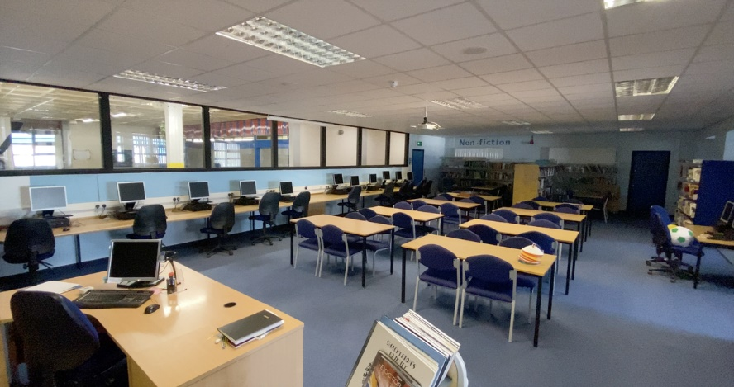
Inside our school library.

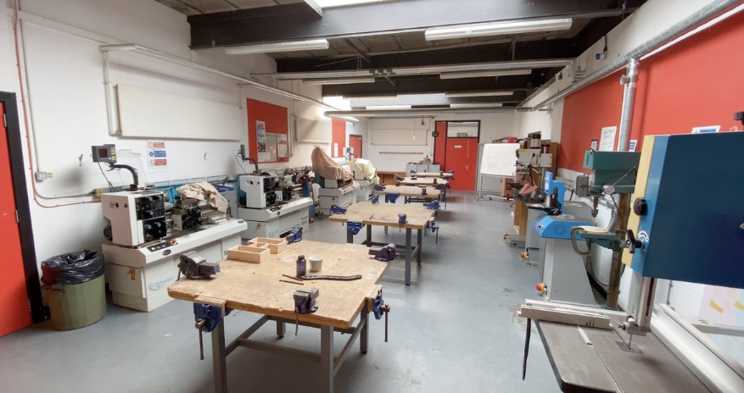
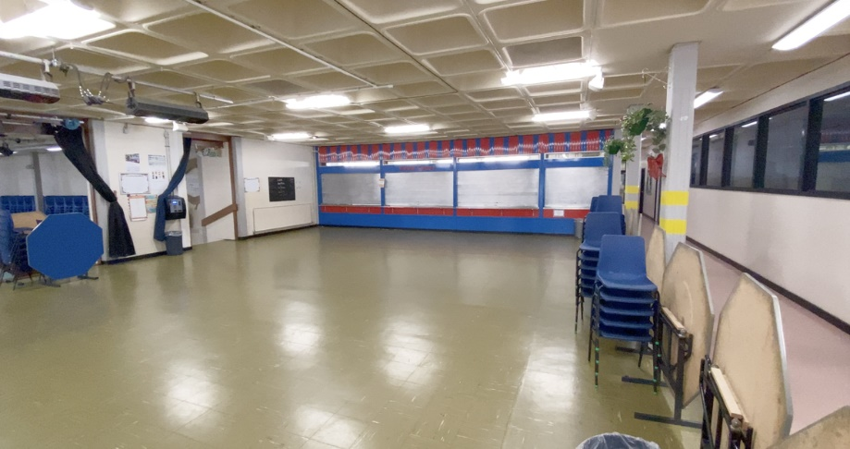
Inside one of our Design & Technology workshops.
School Lunches
From this servery you can buy meals such as fish and chips, steak pie, chicken curry and much more.
At break time, you can buy waffles, drinks and much more.
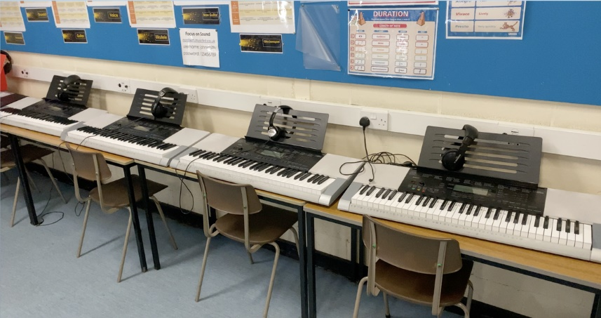
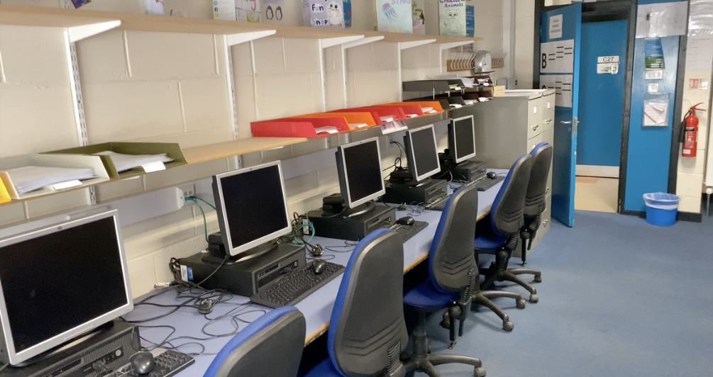
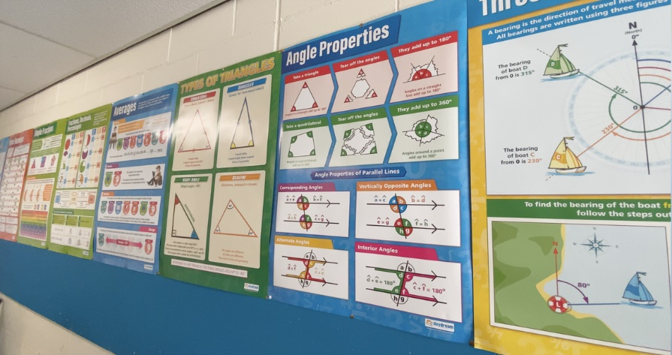
Inside one of our Music classrooms.
One of our ICT rooms.
A Maths classroom.
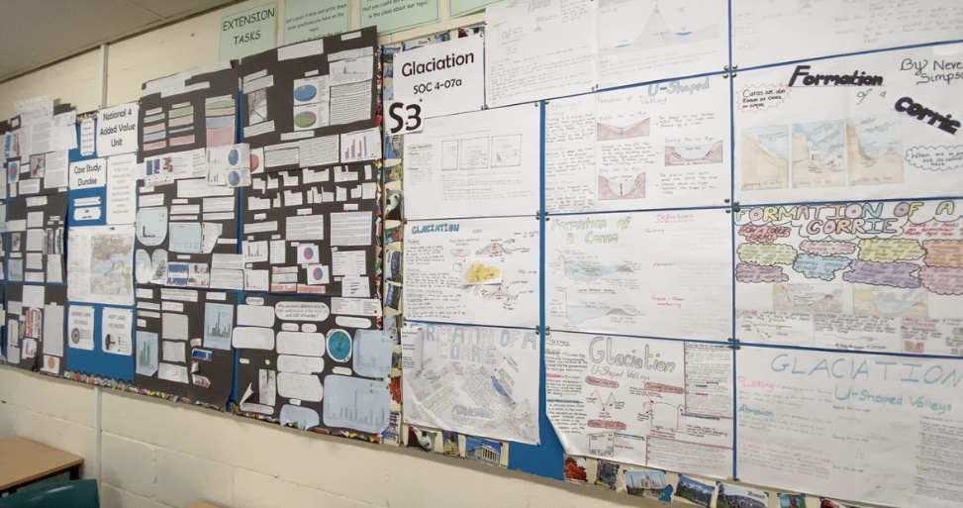
A Geography classroom.

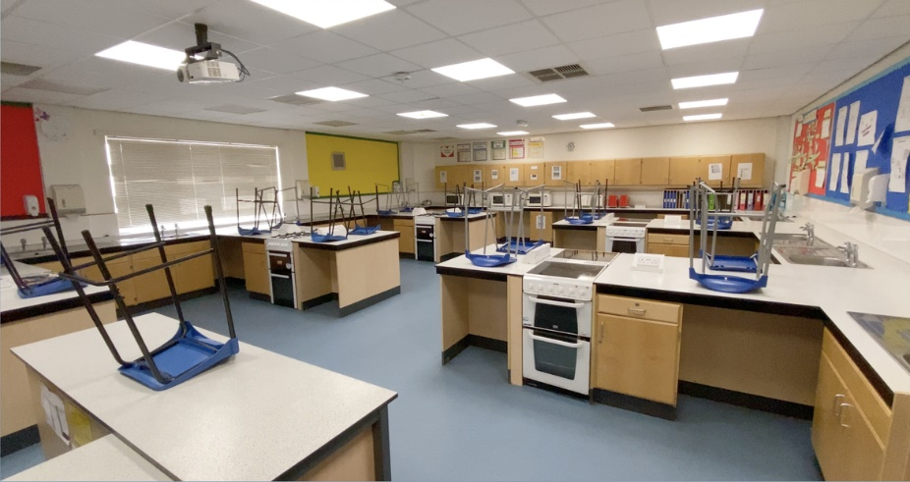
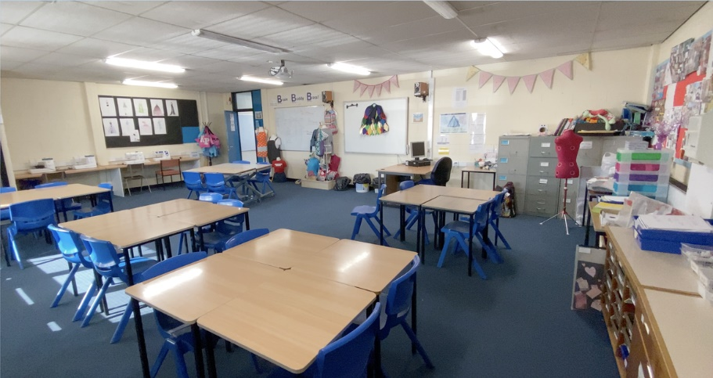
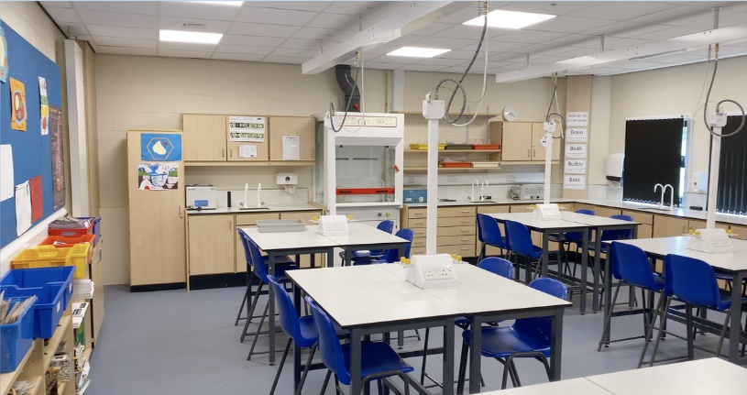
Home Economics
Our sewing room and one of our kitchens.
Inside one of our many Science labs.
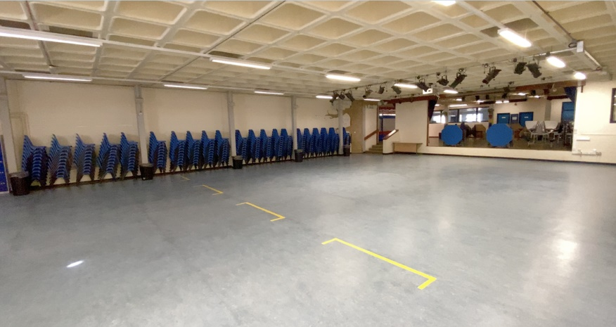
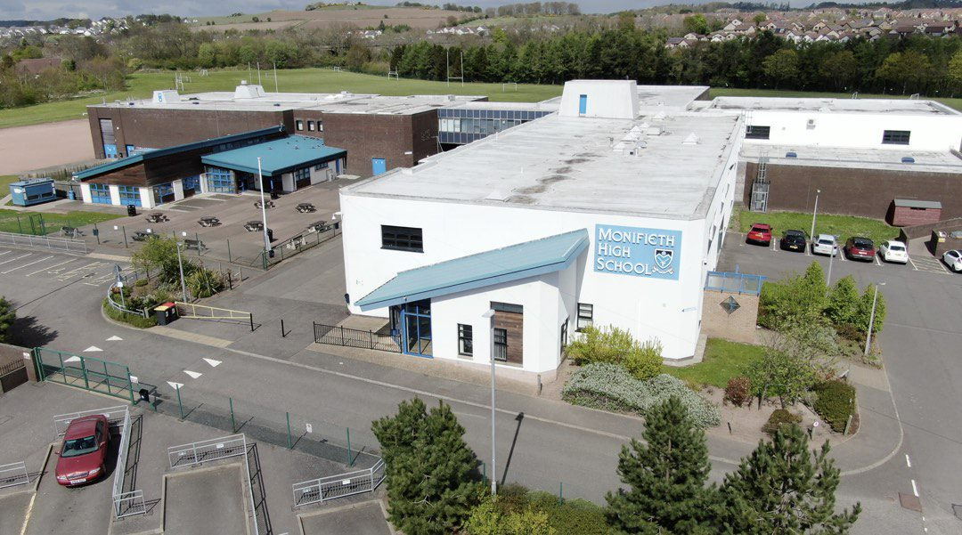
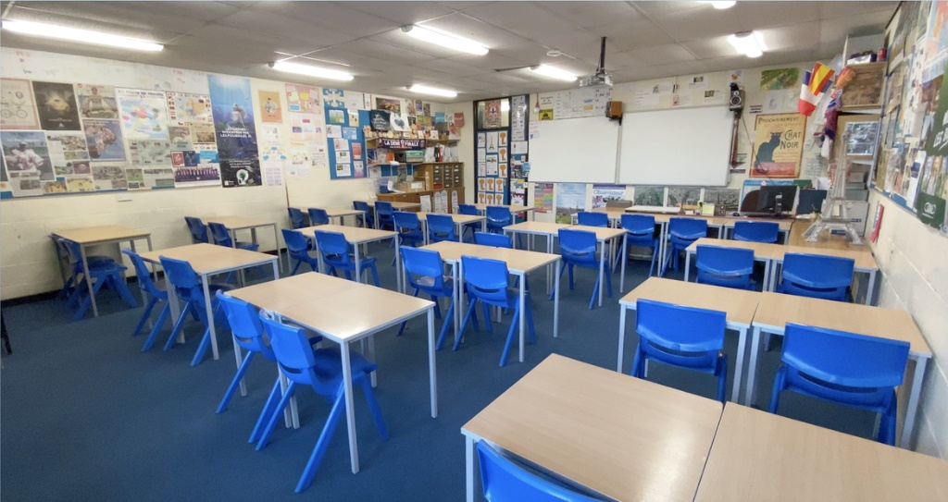
PE department
Playing fields
Main entrance to school
Bus Bays
This is our Lower Social Area. This area is used for pupils eating their packed lunches, assemblies, school shows/concerts and many other school events.
Inside one of our Modern Languages classrooms. In S1 you will learn French and Spanish.
Clubs at Monifieth High School
Unscramble the words to find out some of the extra-curricular clubs or places to visit during break/lunc at Monifieth HS.

ebalt inetns ________________ keca blcu ________________

mgismwni ________________ ybrgu _________________

lbatenl _______________ gltpaomrni ________________

cktecri _________________ ncadnngi _________________

brlyria ________________ ardma _________________

tra bluc ________________ cbesarbl _________________

nbedatgi ________________ ytcath eacf _______________

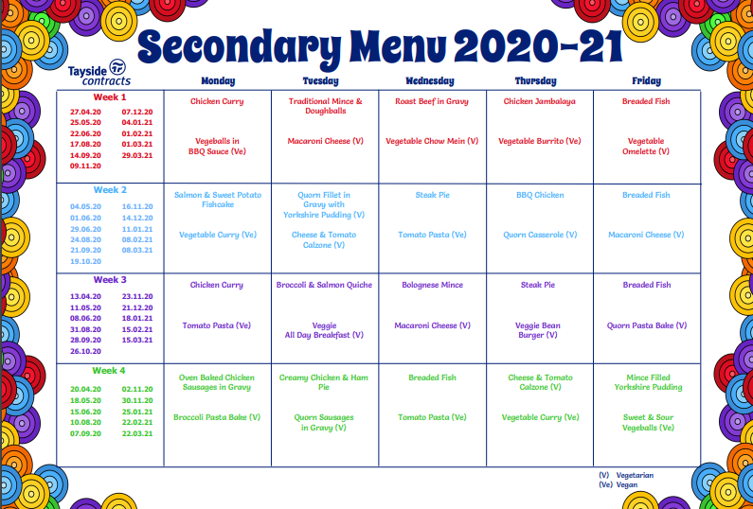
School Meals
This is a copy of Tayside Contracts Secondary School main meals menu. You can also choose from:-
- various filled rolls, sandwiches and wraps
- baked potatoes
- soup
- pizza,
- salad bar
- noodles and much more.
Learning Qualities at Monifieth HS
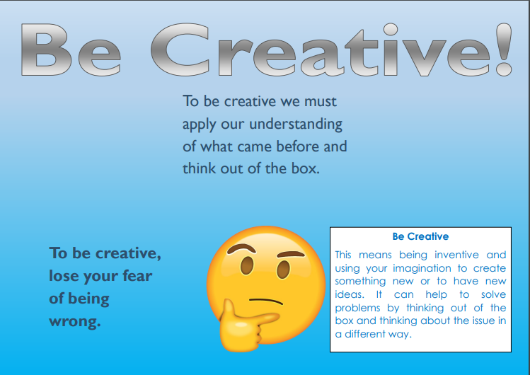

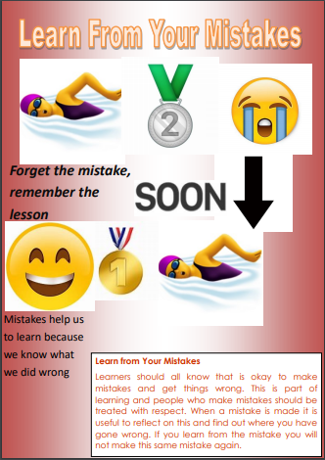
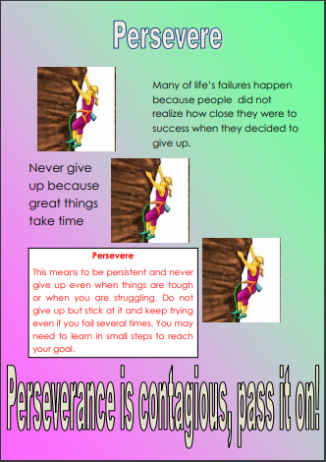
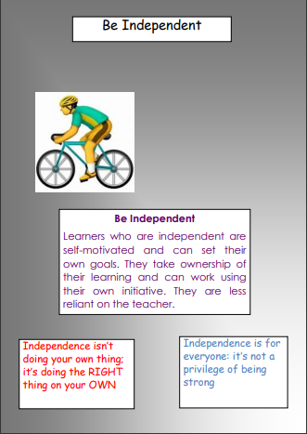
Any questions?
We hope this booklet answers some of the questions you may have but please get in touch if you have other questions or queries.

Pupil Care & Support Teacher Email Addresses:-
Mrs Welsh m.welsh@angusschools.org.uk
Mrs Whitfield r.whitfield@angusschools.org.uk
Mr Burns s.burns1@angusschools.org.uk
Mrs Perry k.perry@angusschools.org.uk
Mr Tragham a.tragham@angusschools.org.uk
Miss Herbert l.herbert@anguschools.org.uk

Transition Mailbox MHSP7transition@angusschools.org.uk

Follow us on Twitter @monifiethhigh
@pcs_mhs
@monifiethHWB

#staysafe and we are looking forward to meeting you all soon.
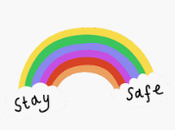

We hope you have a lovely summer holiday and we are looking forward to meeting you all in August.
Take care and stay safe

