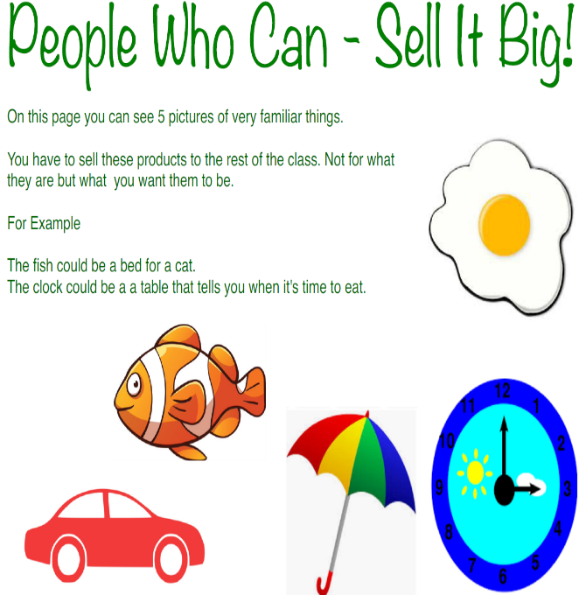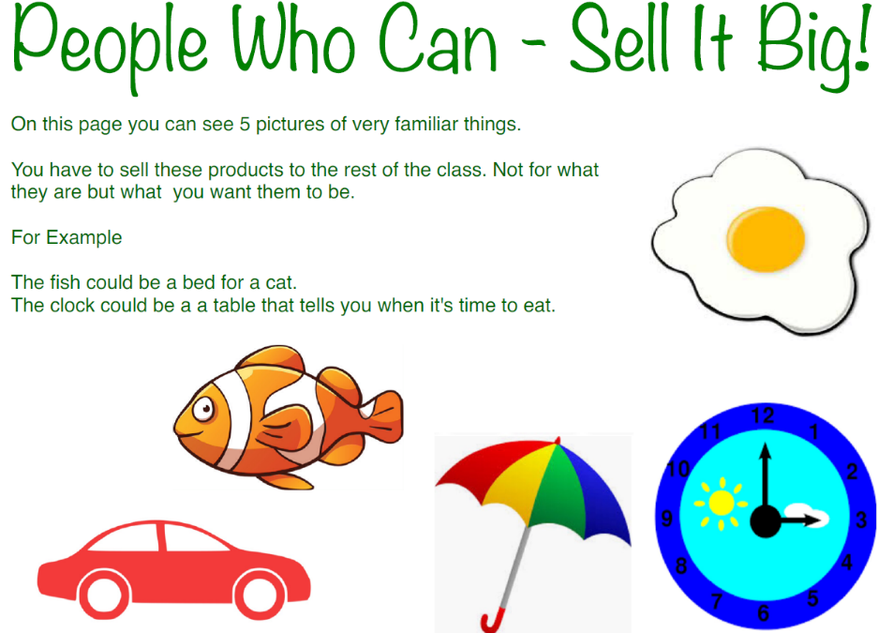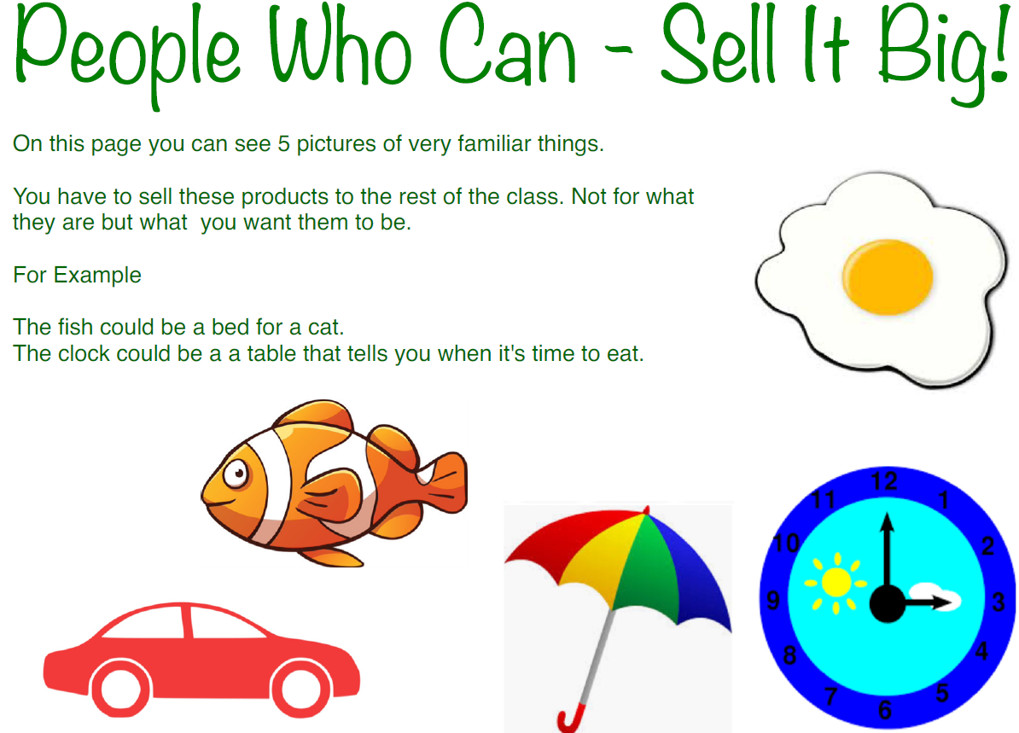

Firstly answer these questions to help you decide what the products will become.

**Circle** your preferred choice.

What will you use the product for? To Eat To Carry To Sit On

To Wear To Play With To Move

Something Else _____________________

Who will use it? Men Women Boys Girls Anybody Animals

What qualities must it have? Soft Hard Waterproof

Strong Healthy Accurate

Something Else ______________________

Where will it be used? Inside Outside Home

Work School Car

Somewhere Else ______________________

You can Sketch, Copy, Trace or Print Out the images on the Publisher file.

On this page there are 5 images of some very common items:

**A Clock; an Umbrella; a Fish; an Egg and a Car.**

You have to sell these items to the rest of the class, but not as they are but as something completely different. You have to **REDESIGN** them

For Example:

The Fish could be a Bed for a Cat.

The Clock could be a Table Top for teaching Children about Meal Times.

**PRIMARY TRANSITION**

**WEIRD AND WACKY DESIGNS**