What France means to me……
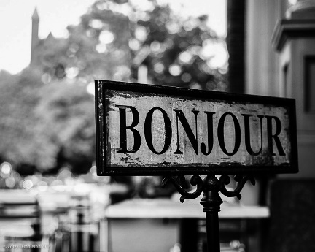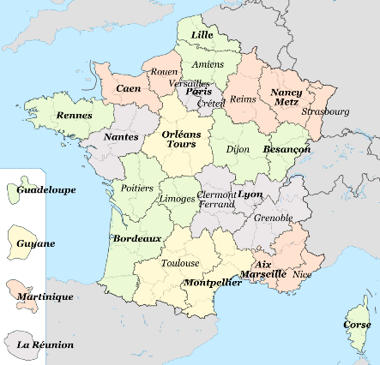

We would like you to prepare a piece of work called “What France means to me””
It should be on a piece of paper about A4 size.
You can make it on the computer or you can write and draw things, make a collage, a cartoon or a pin board. 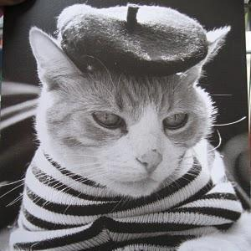 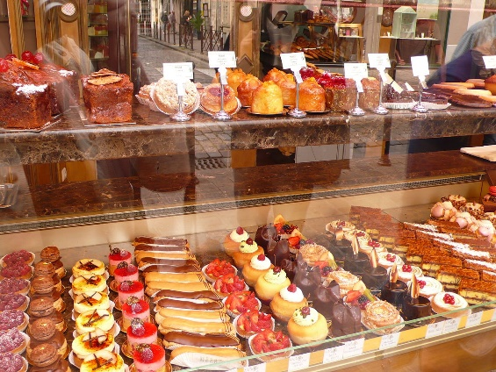

Put together ideas which you think of when you think of France. You may have been there on holiday, read stories or seen films set in France. You may want to mention famous places or French landmarks. You can talk about famous French people. You might know about French food or things made in France. You could also use maps and charts to show things. Anything like this will be fine.
We want you to bring this in to school with you when you are able to come in. We look forward to seeing what you have made!
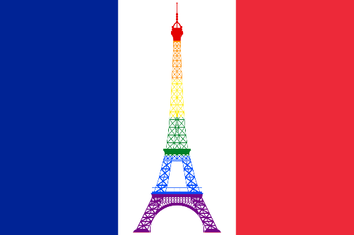
Good luck with your ideas and designs
The Modern Languages Department, Monifieth high School

